CHAPTER THREE
METHODOLOGY

3.1 Overview
This chapter outlines the methodology used to design and implement EduVid, the educational video platform for Dominion University. It covers the development approach, lifecycle, requirements, architecture, and design strategies to ensure a high-quality and efficient platform. Furthermore, it explains the choice of software tools and provides the database schema necessary to organize academic content by department and course codes. The platform is structured to support essential functionalities such as user management, structured video management, search and retrieval, as well as peer interaction.

3.2 System Development Approach
The Software Development Life Cycle (SDLC) is defined as a systematic, disciplined, and quantifiable approach to the development and maintenance of software (IEEE, 2022). It outlines a sequence of phases, including design, development, testing, and deployment, which provides a clear roadmap for the successful completion of a project.
The development of EduVid adopts the Agile Development Methodology to ensure a flexible and iterative development process. Agile is an iterative and lean software design framework that emphasizes people, communication, and the rapid delivery of functional components over rigid documentation (Al-Zewairi et al., 2017). Unlike traditional models, Agile allows for continuous refinement of the platform based on testing and user feedback, which is essential for a student-centered peer-learning environment.

3.2.1 The Agile Development Model
The development process is partitioned into several repetitive cycles known as sprints. As noted by Guerrero-Ulloa et al. (2023), this approach allows a system to be divided into manageable modules, ensuring each deliverable is tested before the entire system is finalized.
- Planning & Requirement Analysis: In this initial phase, the project scope is defined. The functional and non-functional requirements are gathered from stakeholders to establish a "Product Backlog” which is a prioritized list of features necessary for the platform’s success.
- System Design: The architectural framework of the system is established. This involves creating the UI/UX blueprints, defining the database schema, and mapping out the communication protocols between the client application and external services.
- Development: The actual coding of the software components takes place. Developers build the features defined in the planning phase, ensuring that the code adheres to established standards and modularity
- Testing: Once a module is developed, it undergoes rigorous testing. This includes unit testing for individual components and integration testing to ensure that different parts of the system (such as the frontend and backend) work together seamlessly.
- Deployment and Review: A functional version of the increment is deployed to a staging or production environment. A review is conducted to evaluate the progress against the initial requirements, and feedback is used to refine the goals for the subsequent sprint.

Agile Development Workflow
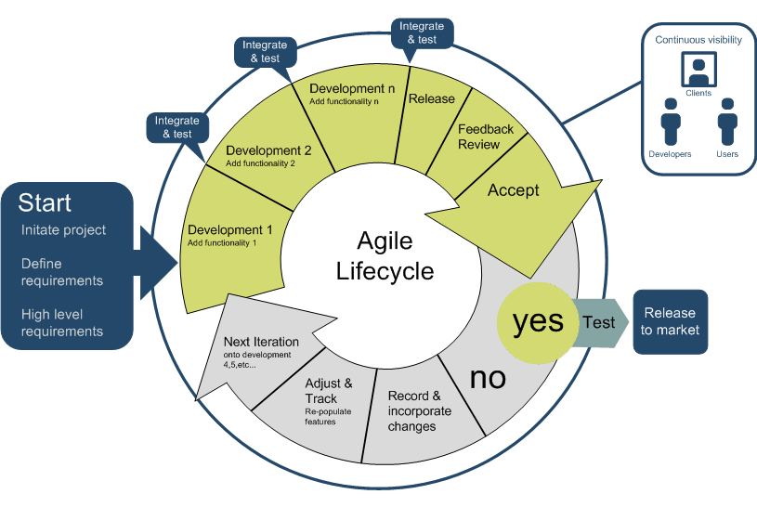
Figure 1: Agile Development Workflow (Abishek, 2021)

The following are some of the most frequent characteristics of agile development methodologies:
- Incremental Delivery: Instead of waiting until the end of the project to produce a result, functional versions of the system are produced at the end of every cycle. This allows for early detection of design flaws.
- Adaptability: Agile acknowledges that requirements may evolve. The methodology allows for the re-prioritization of tasks, which is essential when integrating complex external APIs and cloud services.
- User-Centric Focus: By incorporating frequent review cycles, the development remains focused on the needs of the end-user (students and administrators), ensuring the final product is both intuitive and effective.
- Continuous Improvement: Each sprint provides an opportunity to reflect on the development process, allowing for the optimization of workflows and the enhancement of system performance over time.
- People-oriented: Agile development techniques provide developers a lot of control. Developers make all the technical decisions, estimate the amount of work to be done, sign up for iteration tasks, and decide how much procedure to follow in a project. As a result, it is more concerned with people than with processes. (Dudhat and Ali, 2021)
By using Agile, the project benefits from continuous improvement, flexibility in adapting to changing requirements, and close collaboration between developers and users.

3.3 Requirement Specifications
The system requirements define both the functional and non-functional aspects of the platform, ensuring that it meets user needs effectively.

3.3.1 Functional Requirements
Functional requirements define the specific actions and functionalities that the platform must performs. These requirements detail how the platform will operate from the user’s perspective and the features available to them. Key requirements include:
- OAuth 2.0 Authentication: Secure registration and login using Google accounts.
- API-Driven Video Upload: Ability for peer tutors to upload videos directly to the Dominion University YouTube channel via the app.
- Academic Metadata Tagging: Mandatory tagging of videos with Department, Course Code, Level, and Topic.
- Search and Discovery Engine: Filtering and search functionality based on course codes and academic keywords.
- Peer Interaction Module: Features allowing students to post comments and rate videos for clarity and accuracy.
- Administrator Governance Dashboard: A specialized interface for university admins to moderate content by "flagging" videos and managing user permissions.
- Token Management: Automatic refreshing of OAuth 2.0 access tokens to maintain active user sessions.
- Link Integrity Synchronization: The system must verify the existence of the video on YouTube and automatically hide or update entries in the app if the source video is modified.
- Real-Time Updates: Instant synchronization of comments and video metadata across all user devices using Cloud Firestore.

3.3.2 Non-Functional Requirements
These requirements focus on how the app should operate and user experience considerations. These include:
- Usability: An intuitive interface utilizing a "3-click rule" to ensure students can find course materials quickly.
- Responsiveness: A mobile-first design using Bootstrap 5 to ensure the platform works seamlessly on smartphones, tablets, and PCs.
- Performance: Metadata queries and search results must be returned in under 2 seconds.
- Scalability: The architecture must handle an increasing number of concurrent users by leveraging YouTube’s streaming infrastructure.
- Security: All communications must be encrypted via SSL/TLS, and API credentials must be stored in secure environment variables.
- Availability: The platform must maintain uptime with minimal interruptions, utilizing Google’s high-availability cloud servers.
- Reliability: The system must handle API errors or network timeouts gracefully without crashing the user interface.

3.4 System Architecture
System architecture provides a high-level view of the platform’s components and the relationships between them. EduVid employs a Three-Tier Client-Server Architecture, specifically optimized for cloud-native applications. This modular design separates the presentation layer, the logic/authentication layer, and the external media storage layer to ensure scalability and ease of maintenance (Bass et al., 2021).

3.4.1 Client-Side (Front-end Web Application)
The client-side is the graphical user interface (UI) that students at Dominion University interact with via their web browsers.
- Vue.js 3: The platform is built as a Single Page Application (SPA) using the Vue.js 3 Composition API. This allows for reactive data binding, meaning when a student searches for a course or posts a comment, the UI updates instantly without a full page refresh.
- Bootstrap 5: To ensure a mobile-first experience for Dominion University students, Bootstrap 5 provides a responsive grid system. This ensures the platform is accessible across various devices, including smartphones, tablets, and laptops
- OAuth 2.0 Integration: The frontend handles the Google Identity handshake. It captures the user's Google authentication token, which is then passed to the backend services to authorize YouTube video uploads
- State Management: The frontend tracks the "Application State," such as whether a user is logged in, the current course being viewed, and the progress of a video upload

3.4.2 Server-Side (Cloud Backend and API Services)
The server-side consists of managed cloud services that handle authentication, data persistence, and media processing.
- Firebase Authentication: Acts as the gateway for identity management. It verifies the Google credentials provided by the frontend and maintains the user session.
- Cloud Firestore (NoSQL Database): This serves as the primary data store for the platform’s metadata. Firestore stores structured documents for:
  - User Profiles: Names, Matric numbers, and Roles (Student/Admin).
  - Video Metadata: YouTube Video IDs, Course Codes (e.g., SEN 401), and Titles.
  - Interactions: Comments and Ratings linked to specific Video IDs.
- YouTube Data API v3 (Media Storage & Processing): This is the specialized backend tier for video.
  - Storage: Instead of storing raw video files on a local server, they are pushed to a dedicated university YouTube channel.
  - Transcoding: YouTube automatically converts uploaded videos into various formats (360p, 720p, 1080p) to ensure smooth playback regardless of the student's internet speed.
- Firebase Hosting: The entire application is deployed via Firebase Hosting, which provides global delivery through a Content Delivery Network (CDN) and enforces SSL encryption for all traffic.

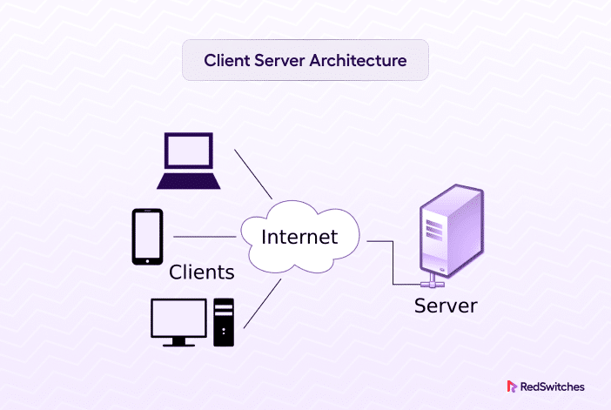
Figure 2: Client-Server Architecture (Anon, 2024)

3.4.3 Data Flow Overview
The interaction between the two sides follows a strict request-response cycle:
- Frontend sends a request (e.g., "Search for CSC 101").
- Firebase (Backend) queries the Firestore collection and returns a JSON object containing the matching YouTube VideoIDs.
- Frontend receives the IDs and uses the YouTube IFrame API to embed the video players directly into the student’s dashboard.

3.5 Database Design
The database acts as the central repository for all academic and user data, facilitating structured organization and fast retrieval of course materials. EduVid utilizes Cloud Firestore, a NoSQL document-oriented database, to ensure scalability and high performance.

3.5.1 Database Management System (DBMS)
For the EduVid project, Cloud Firestore was selected over traditional SQL databases (like MySQL) for the following reasons:
- Flexible Schema: As a NoSQL database, Firestore allows for flexible data structures. This is critical for storing diverse metadata (tags, comments, ratings) that may evolve as the platform grows.
- Scalability: The serverless nature of Firestore allows the platform to handle an increasing number of students and large volumes of video metadata without performance degradation.
- Real-time Synchronization: Firestore is optimized for real-time data synchronization, making it ideal for university environments where data needs to be updated instantly across multiple devices.

3.5.2 Database Schema (Collections)
The database is logically structured into collections and documents. Each document contains key-value pairs representing specific data entities.
1. Users Collection
This collection manages the identity and permissions of everyone on the platform.
Fields: Fields: uid (Google/Manual ID), firstName, lastName, email, matricNumber, role (Student/Admin)
2. Videos Collection: Stores metadata linking the app to the YouTube Data API.
Fields: videoId (YouTube ID), courseCode (FK), uploaderId (FK), isFlagged (Boolean), status (active/deleted)
3. Courses Collection: Acts as the academic backbone of the platform.
Fields: courseCode (Primary Key, e.g., SEN401), courseTitle.
4. Interactions Collection (Comments & Ratings)
A polymorphic collection for peer feedback and moderation.
Fields: interactionId, videoId (FK), userId (FK), interactionType (comment/flag), content, createdAt

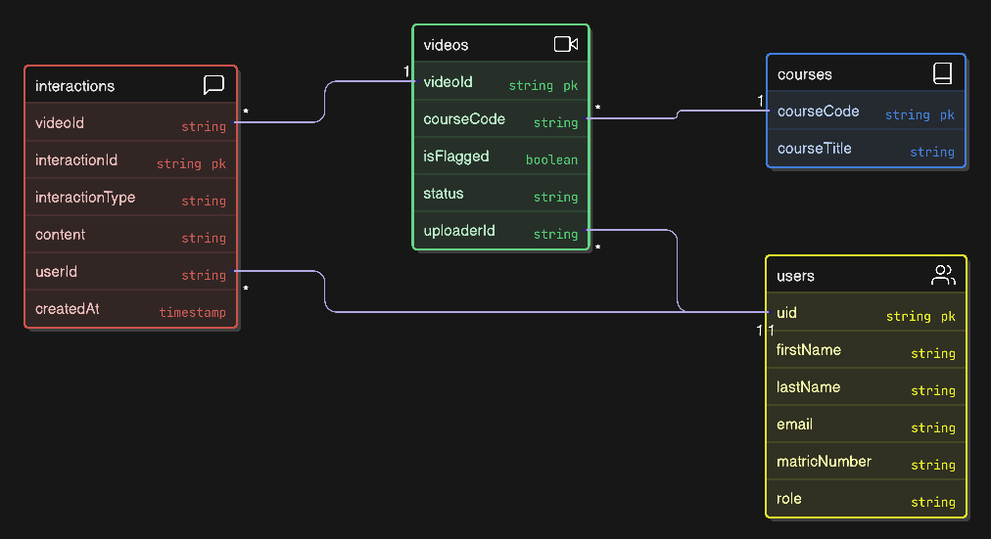
Figure 3: Entity relationship diagram for the educational video platform

3.6 System Modeling
System modeling is a critical phase in the software development lifecycle that abstracts the system's complexity to provide a visual representation of its structure and behavior. For the EduVid platform, the Unified Modeling Language (UML) was employed to visualize the interactions between the primary actors (students and administrators) and the system components

3.6.1 Use Case Diagram
The Use Case Diagram visually represents the functional interactions between the system's actors and the EduVid platform. The design focuses on a Student-Centric model, where the student acts as both a consumer and a creator of knowledge
Key Actors:
Student (The User): Can register via Google or Manual forms, search by Course Code, watch videos, upload peer-learning content, and post interactions (comments or flags).
Administrator (The Moderator): Responsible for academic governance, including managing the Course Catalog and reviewing the Flagged Video Queue to perform "Delete or Retain" decisions.

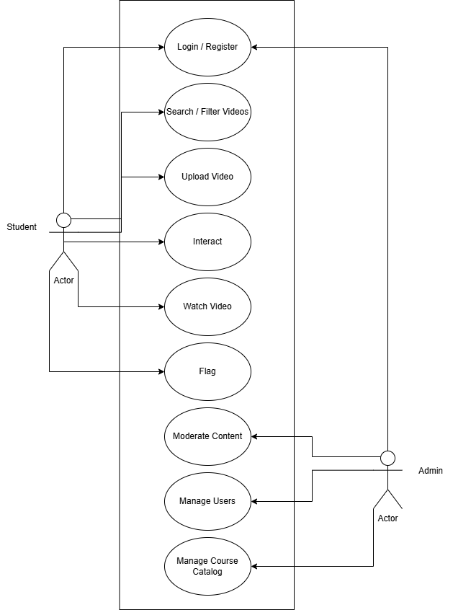
Figure 4: Use case diagram for an educational video platform

3.7 Software Tools and Technologies
The implementation of the EduVid platform relies on a stack of modern web technologies chosen for their performance, modularity, and ease of deployment.
- Vue.js 3 (Frontend Framework): Vue.js is utilized as the primary frontend framework to build a Single Page Application (SPA). Its reactive component system allows for a seamless user experience, where the interface updates dynamically without requiring the browser to reload pages entirely.
- Bootstrap 5 (UI Framework): To ensure accessibility across devices, Bootstrap 5 provides the responsive grid system and pre-styled components. This ensures that the platform adapts automatically to different screen sizes, allowing students to access materials on smartphones, tablets, or laptops with equal ease.
- Firebase (Backend-as-a-Service): Firebase provides the comprehensive backend infrastructure, eliminating the need to manage physical servers. It handles Authentication for secure login, Firestore for the real-time database, YouTube Data API v3 is utilized for hosting and transcoding large video files, while Firebase Cloud Storage is reserved for static assets such as user profile pictures.
- Firebase Hosting: The application is deployed using Firebase Hosting, which provides a production-grade, SSL-encrypted environment. This ensures that the platform is secure and load times are optimized via a global Content Delivery Network (CDN).
- GitHub (Version Control): GitHub is employed for version control, allowing for the tracking of code changes, management of project iterations, and safekeeping of the codebase throughout the development lifecycle

